**module** instr_mem(

**input** **logic** [**31**:**0**] addr_i,

**output** **logic** [**31**:**0**] read_data_o

);

**logic** [**31**:**0**] memory [**0**:**1023**];

**initial** **begin**

$readmemh("program.mem",memory);

**end**

**assign** read_data_o=memory[ addr_i[**11**:**2**] ];

**endmodule**

**endmodule**

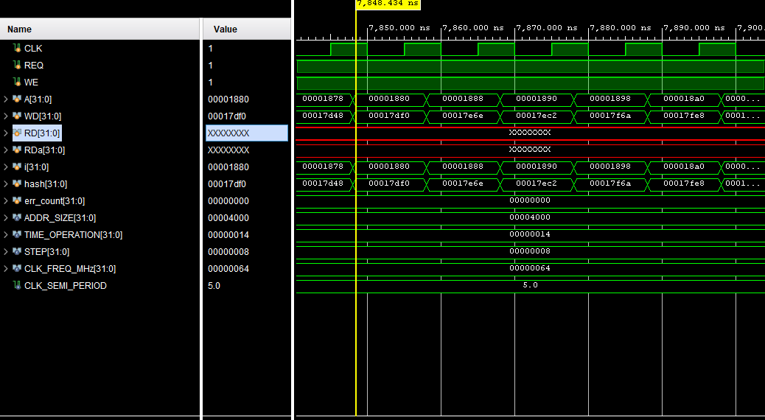

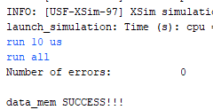

**module** data_mem(

**input** **logic** clk,

**input** **logic** mem_req_i,

**input** **logic** write_enable_i,

**input** **logic** [**31**:**0**] addr_i,

**input** **logic** [**31**:**0**] write_data_i,

**output** **logic** [**31**:**0**] read_data_o

);

**logic** [**31**:**0**] ram[**0**:**4095**];

**logic** [**13**:**2**]counter;

**logic** [**31**:**0**]data;

**logic** [**1**:**0**] cmd;

**assign** cmd={write_enable_i,mem_req_i};

**assign** counter=addr_i[**13**:**2**];

**always_ff** @(**posedge** clk)

**begin**

**case**(cmd)

**2'b01**: **begin**

read_data_o<=ram[counter];

data<=ram[counter];

**end**

**2'b11**: **begin**

read_data_o<=ram[counter];

ram[counter]<=write_data_i;

data<=ram[counter];

**end**

**default**:

read_data_o<=data;

**endcase**

**end**

**endmodule**

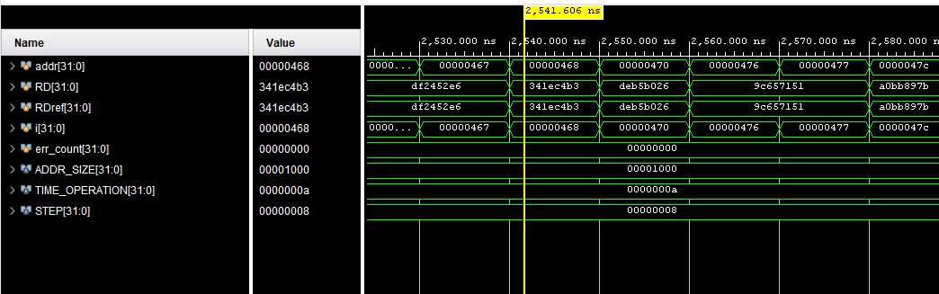

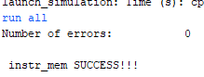

**module** rf_riscv(

**input** **logic** clk,

**input** **logic** [**4**:**0**] addr_1,

**input** **logic** [**4**:**0**] addr_2,

**input** **logic** [**4**:**0**] write_addr,

**input** **logic** write_enable,

**input** **logic** [**31**:**0**] write_data,

**output** **logic** [**31**:**0**] read_data_1,

**output** **logic** [**31**:**0**] read_data_2

);

**logic** [**31**:**0**]rf_mem[**0**:**31**];

**logic** [**31**:**0**]buf1;

**logic** [**31**:**0**]buf2;

**assign** buf1=rf_mem[ read_data_1 ];

**assign** buf2=rf_mem[ read_data_2 ];

**always_comb**

**begin**

**case**(read_data_1)

**0**: read_data_1<=**0**;

**default**:

read_data_1<=buf1;

**endcase**

**end**

**always_comb**

**begin**

**case**(read_data_2)

**0**: read_data_2<=**0**;

**default**:

read_data_2<=buf2;

**endcase**

**end**

**always_ff** @(**posedge** clk)

**begin**

**if** (write_enable==**1**)

**begin**

rf_mem[ write_addr ]<=write_data;

**end**

**end**

**endmodule**

\